
CSA15 Cloud Computing and Big Data Analytics
CO1 AT2 - Digital Concept Map and Service Model Matrix
Individual Student Submission Template

Student and Faculty Details
Student Name | K.Varshini | Register Number | 192472358
Class / Section |  | Slot | B
Course Code | CSA1512 | Course Title | Cloud computing
Capstone Title | Skill Hire: AI Resume Screening and Job-Fit Android App
Submission Date
Faculty Name | Dr.C.Rajesh Babu | Employee ID
Department | CSE-AI

Assessment Brief
Course Outcome | CO1 - Explain the evolution, architecture, characteristics, service models, and emerging paradigms of cloud computing.
Assessment Type | Individual concept mapping, service-model responsibility analysis, and capstone-cloud interpretation.
Assessment Focus | Each map must show key nodes, link labels, relationship meaning, and a logical hierarchy. The response must connect cloud fundamentals to the student's own perception of the capstone title.
Submission Mode | Editable DOCX + exported diagram evidence + GitHub repository link submitted in Google Classroom.
Permitted Tools | draw.io / diagrams.net, Lucidchart, Miro, Canva, PowerPoint, Google Drawings, or equivalent diagramming tool.
Individual Rule | Every student must submit their own concept map, matrix, capstone-cloud mapping, and reflection. The capstone title may be shared by a team, but the assessment answer must not be common.
Total Marks | 100 marks

Code of Conduct and Student Assurance
Academic Integrity Statement
This assessment must be completed individually. Students may discuss the capstone domain with their team, but the concept map, service model matrix, explanations, GitHub evidence, and reflection submitted here must be individually prepared.
Student Assurance | I confirm that this submission represents my own understanding of CO1 concepts and my individual interpretation of the selected capstone title.
Tool Use | I have used digital tools only for diagram preparation, organization, and presentation. I have not copied another student's diagram, matrix, or explanation.
Evidence | I have uploaded the required files to my GitHub repository and submitted the repository link / evidence link through Google Classroom.
Student Signature
Date | 13-07-2026

Procedure for Preparing the Digital Concept Map
Use the following procedure to prepare the diagram and upload evidence. Students who already know another diagramming tool may use it, but the exported evidence and source file must still be submitted.
- Open https://app.diagrams.net/ or the desktop version of draw.io / diagrams.net.
- Choose Device, Google Drive, or OneDrive as the save location according to availability.
- Create a blank diagram and name the file as CSA15_CO1_AT2_RegisterNumber_Concept_Map.drawio.
- Place the capstone title at the center or as a clearly visible anchor node.
- Add major cloud nodes: cloud definition, cloud evolution, cloud architecture, service models, deployment models, virtualization, web services, SOAP, REST, APIs, elasticity, scalability, resource pooling, measured service, and emerging paradigms.
- Connect nodes with labeled arrows such as uses, depends on, enables, scales through, communicates through, belongs to, supports, provides, consumes, or controls.
- Use colors meaningfully: one color for service models, one for cloud characteristics, one for API/web-service concepts, and one for capstone-specific elements.
- Export the final diagram as PNG or PDF. Keep the editable .drawio source file also.
- Paste the exported diagram image or screenshot in this DOCX under Task 1.
- Upload the DOCX, exported PNG/PDF, and .drawio file to GitHub, then submit the GitHub link in Google Classroom.

GitHub Submission Procedure
Step | Required Action | Expected Evidence
1 | Create or use your individual GitHub account. | GitHub profile link.
2 | Create a repository named CSA15-CO-Assessments-RegisterNumber or use the repository instructed by faculty. | Repository URL.
3 | Create a folder named CO1_AT2 inside the repository. | Folder visible in repository.
4 | Upload this completed DOCX, exported diagram PNG/PDF, and editable .drawio source file. | At least three evidence files uploaded.
5 | Add a short README.md explaining the capstone title and files submitted. | README visible in the AT2 folder.
6 | Submit the GitHub folder link in Google Classroom. | GCR submission with repository/folder link.

Assessment Questions and Student Response Sections
Important
The capstone project may be developed by a team, but every response below must be written from the individual student's own perspective. Do not submit a common team answer.

Task 1 - Digital Cloud Concept Map
Create one integrated digital concept map for CO1. The map must show key nodes, link labels, relationship meaning, and a logical hierarchy. It must also connect the concepts to your selected capstone title from your individual perspective.
Mandatory Concept Group | Minimum Concepts / Nodes to Include
Cloud Fundamentals | Definition, characteristics, benefits, limitations, on-demand access, measured service.
Cloud Evolution and Drivers | Hardware evolution, internet software evolution, distributed systems, cost economics, mobility, remote access, big data growth.
Architecture and Deployment | Front-end, back-end, network layer, data center, management software, public/private/hybrid/community cloud.
Service Models and Responsibility | IaaS, PaaS, SaaS, XaaS, provider responsibility, user responsibility, shared responsibility.
Virtualization and Web/API Layer | Virtual machine, hypervisor, abstraction, resource pooling, multi-tenancy, web services, SOAP, REST, API request/response.
Capstone Connection | Your capstone users, app/module, cloud backend, database/storage, dashboard/analytics, scalability and elasticity idea.
Paste exported concept map image / screenshot here. Resize neatly within this white space.

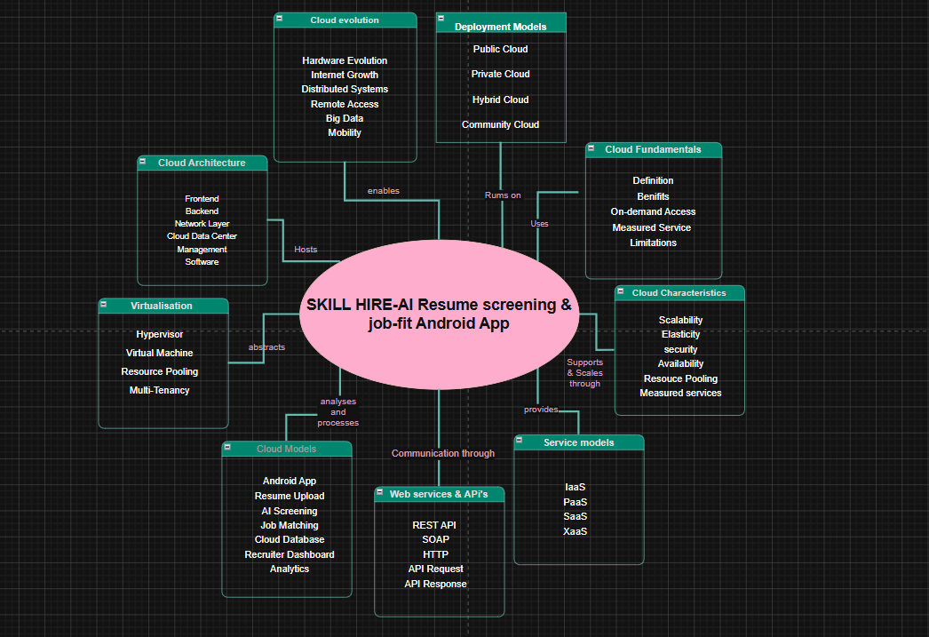

Brief explanation of your concept map: explain the most important nodes, link labels, hierarchy, and capstone connection.
The concept map illustrates the cloud computing concepts used in the SkillHire AI Resume Screening and Job-Fit Android App. The Android application acts as the client, allowing users to upload resumes that are processed through REST APIs by the cloud backend. The backend stores resume and job information in a cloud database and uses AI-based resume screening to calculate job-fit scores. Cloud characteristics such as scalability, elasticity, resource pooling, and measured service enable efficient handling of multiple users. The diagram also represents cloud architecture, deployment models, service models, virtualization, and web services, showing how they support the overall functioning of the Skill Hire platform.

Task 2 - Service Model Matrix
Complete the matrices by making technical decisions for your capstone project. Select only the rows that are relevant to your capstone design. If a row is not used, write a short technical reason instead of leaving it blank.
Your answer should show how responsibility shifts between cloud provider and student development team, and how the chosen services support the capstone workflow, API design, storage, security, scalability, and evidence submission.

Task 2A - Service Model Responsibility Matrix
Service Model | Capstone Role / Module | Provider Responsibility | Student Responsibility | Evidence to Submit
IaaS | Virtual Machines for  Backend Hosting | Provides virtual machines, storage, networking, server maintenance | Deploy backend application, configure servers, manage application | VM deployment screenshot or cloud dashboard
PaaS | AI Backend & REST API | Provides runtime environment, automatic scaling, deployment platform | Develop Python AI model, REST APIs, business logic | API testing screenshots (Postman/FastAPI)
SaaS | Recruiter Dashboard & Authentication | Provides authentication, cloud office services, user management | Configure authentication, manage users and permissions | Firebase Authentication or login screenshots
XaaS / Specialized Service | Resume Screening & Job Matching | Provides AI/ML services, resume parsing, language processing | Integrate AI model, define matching logic, evaluate job-fit score | Resume analysis output and AI prediction screenshots

Task 2B - Capstone Cloud Service Decision Matrix
Cloud Layer / Function | Selected Tool or Service | Data / Resource Handled | API or Integration Path | Security / Scaling Note
Client access and UI | Android Studio (Android App) | User login, resume upload, job search | REST API | Analytics Dashboard
API / backend logic | FastAPI (Python) | Resume screening, job-fit calculation | HTTP REST API | Auto scaling using cloud platform
Authentication and identity | Firebase Authentication | User accounts and login | Firebase SDK | Email/password authentication with encrypted sessions
Database / structured records | Firebase Firestore | User profiles, resumes, job postings, match scores | Firebase API | Real-time database with automatic scaling
File / object storage | Firebase Storage | PDF resumes, profile images | Firebase Storage API | Secure cloud storage with access rules
Monitoring / logs / usage metrics | Firebase Crashlytics / Cloud Monitoring | Error logs, app performance | Firebase Console | Real-time monitoring and issue detection
Analytics / reporting output | Firebase Analytics | App usage, recruiter reports, job match statistics | Analytics Dashboard | Supports decision making and performance analysis
Technical justification: Explain why the selected cloud service pattern fits your capstone project's users, data, API flow, scalability, and security needs.
The selected cloud service architecture is suitable for the SkillHire AI Resume Screening and Job-Fit Android App because it provides high availability, scalability, and secure data management. Android Studio is used to develop the mobile application, while FastAPI serves as the backend to process resumes and calculate job-fit scores. Firebase Authentication secures user access, Firestore stores structured user and job data, and Firebase Storage manages uploaded resumes. REST APIs enable seamless communication between the Android application and the cloud backend. Cloud-based services support automatic scaling during high user traffic, ensuring reliable performance while maintaining data security and efficient AI-based resume analysis.

Task 3 - Capstone Cloud Flow Mapping

Study the sample architecture-flow template below. Redraw it in draw.io / diagrams.net using your own capstone architecture. Replace every generic label with your actual user role, screen, API endpoint, backend logic, cloud storage, analytics output, security control, and scalability or elasticity decision.

Student Drawing Requirement
Do not copy the sample as it is. Use it as a layout model, then create your own capstone-specific flow diagram with meaningful labels, arrows, data movement, API names, and cloud service choices.
Flow Component | Student Entry
User role and action | Job Seeker: Registers/Login → Uploads Resume (PDF) → Searches Jobs → Views AI Job Match Score. Recruiter: Login → Posts Job → Views Applicants → Shortlists Candidates → Downloads Reports.
Frontend / app screen | Android App developed using Android Studio with Login, Register, Resume Upload, Job Search, Match Results, Notifications, Recruiter Dashboard, and Profile screens.
API endpoint and method | POST /api/auth/register – Register User  POST /api/auth/login – Login  POST /api/resume/upload – Upload Resume  GET /api/jobs/search – Search Jobs  POST /api/match/score – Calculate Job Match  GET /api/results/{id} – Retrieve Results  GET /api/notifications – Notifications
Backend processing rule | Validate user request → Authenticate user → Store uploaded resume → Extract text using NLP → Perform AI Resume Screening → Compare resume with job requirements → Calculate Job-Fit Score → Store results → Return JSON response.
Cloud database / storage operation | Firebase Authentication verifies users. Resume PDFs are stored in Firebase Storage. User profiles, resumes, job postings, and AI match scores are stored in Firebase Firestore. Analytics data is stored in Firebase Analytics.
Response, alert, report, or dashboard output | Job Seeker receives Job Match Score, recommended jobs, and notifications. Recruiter Dashboard displays shortlisted candidates, resume ranking, analytics, and downloadable reports.
Security, scalability, and elasticity labels added in diagram | HTTPS communication, Firebase Authentication, Role-Based Access Control, Encrypted Storage, Automatic Cloud Scaling, Load Balancing, High Availability, Elastic Resource Allocation.
Paste your redrawn capstone cloud-flow diagram here.
Job Seeker / Recruiter
│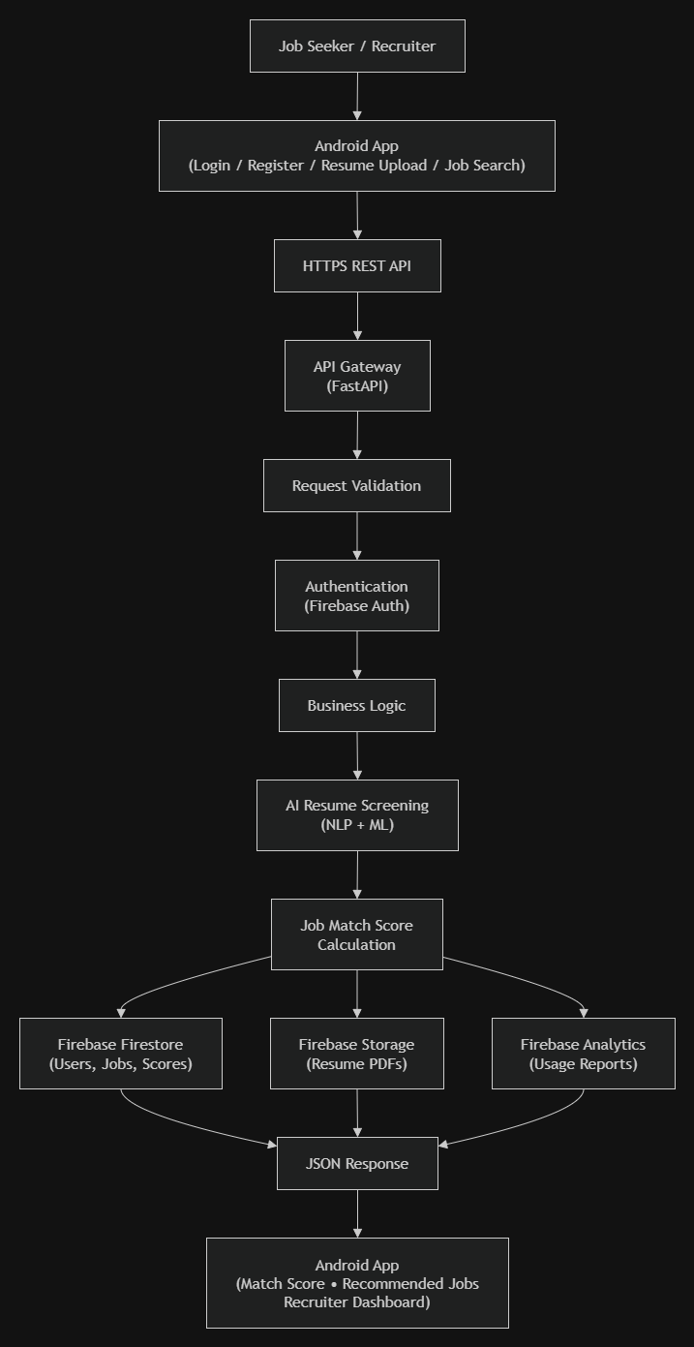
Brief explanation: explain one complete request-response path from user action to cloud response.

The cloud flow of the SkillHire: AI Resume Screening and Job-Fit Android App starts when a job seeker logs into the Android application and uploads a resume. The app securely sends the resume to the FastAPI backend through REST APIs. The backend validates the request, authenticates the user using Firebase Authentication, and stores the resume in Firebase Storage. The AI engine then extracts skills, education, and experience using NLP techniques and compares them with job requirements stored in Firebase Firestore. Based on this analysis, the system calculates a Job-Fit Score and generates suitable job recommendations. The results are returned to the Android application, where users can view their match score and recommended jobs. Recruiters can access the dashboard to view applicants, shortlist candidates, and monitor recruitment analytics. The cloud architecture ensures secure communication, automatic scalability, high availability, and efficient data management, providing reliable performance even when many users access the system simultaneously.

Task 4 - Individual Reflection
Answer the following from your own perspective. Avoid team-common wording.
- What is the strongest cloud concept represented in your capstone project?
The strongest cloud concept represented in my capstone project is cloud scalability, on-demand service, and cloud storage. The SkillHire application relies on cloud computing to securely store resumes, job postings, user profiles, and AI-generated job match results. Cloud services allow users to access the application anytime and from any location through the internet. The cloud backend also supports AI-based resume screening by providing sufficient computing resources to process uploaded resumes efficiently. This makes the application reliable, flexible, and capable of handling increasing numbers of users without affecting performance.
2. Where will elasticity or scalability become important in your capstone product?
Elasticity and scalability become important when many job seekers upload resumes and recruiters perform candidate screening at the same time. During campus placements or large recruitment drives, thousands of users may access the application simultaneously. Cloud elasticity automatically allocates additional computing power, storage, and network resources whenever demand increases and releases them when traffic decreases. This ensures faster response time, uninterrupted service, and cost-effective resource utilization while maintaining high availability and system reliability.
3. Which API or web-service idea is most relevant to your project and why?
The most relevant web-service concept in my project is the REST API because it acts as the communication bridge between the Android application and the cloud backend. REST APIs are used for user registration, authentication, resume upload, job searching, AI resume analysis, job-fit score calculation, and displaying recommendations. REST APIs are lightweight, secure, platform-independent, and easy to integrate with cloud databases and AI services. They enable seamless data exchange between different components of the SkillHire system, making the application efficient and responsive.
4. What did you personally understand better after preparing this concept map and matrix?
After preparing the concept map, service model matrix, and cloud flow diagram, I developed a much better understanding of how cloud computing concepts are applied in a real-world application. I learned the differences between IaaS, PaaS, SaaS, and XaaS, and understood how each service model supports different parts of my project. I also gained practical knowledge about cloud architecture, virtualization, REST APIs, cloud storage, authentication, scalability, and elasticity. Most importantly, I understood how cloud computing enables AI-based applications like SkillHire to provide secure, scalable, and reliable services to both job seekers and recruiters. This assessment helped me connect the theoretical concepts learned in class with the practical implementation of my capstone project.

Evaluation Rubric - 100 Marks
Criteria | Marks | Expected Standard
Concept identification | 20 | Major CO1 concepts are accurately identified: cloud fundamentals, characteristics, evolution, service models, deployment models, virtualization, web services, SOAP/REST, APIs, elasticity, and scalability.
Relationship mapping | 20 | Links between concepts are accurate, meaningful, and labeled. The map should explain how concepts depend on, enable, consume, provide, scale, or control one another.
Hierarchy and organization | 15 | Concepts are arranged in a logical hierarchy with clear grouping, readable flow, and no disconnected keyword clusters.
Technical relevance | 15 | The map strongly reflects cloud course content and avoids decorative or generic non-technical content.
Service model matrix | 15 | IaaS, PaaS, SaaS, and XaaS are compared with provider responsibility, user responsibility, examples, capstone usage, and risks or limitations.
Capstone alignment and individual reflection | 10 | The student's own capstone interpretation is visible in the concept map, flow mapping, justification, and reflection. Team-common answers are avoided.
Visual clarity and digital evidence | 5 | Diagram is neat, readable, exported properly, and supported with GitHub evidence including source and exported files.

Faculty Evaluation Record
Evaluator Name |  | Marks Awarded
Observation |  | Signature

